Tasks on Ansible – 04

1) Create ansible playbook to create ansible vault.

Ansible Vault
Ansible Vault is a feature to encrypt sensitive data (like passwords, API keys, secret variables) used in Ansible playbooks

Real-Time Uses
- Storing credentials securely (e.g., db_user, db_pass)
- Encrypting entire variable files (group_vars, host_vars)
- Protecting SSH keys or API tokens
- Hiding secrets in Git version-controlled Ansible projects
- Used in CI/CD pipelines without exposing secrets
Playbook:
vault_create.yml
---
- name: Create and Encrypt Ansible Vault File
hosts: localhost
gather_facts: false
vars:
vault_password_file: "/home/ubuntu/playbooks/vault-pass.txt"
vault_file: "/home/ubuntu/playbooks/my_secrets.yml"
tasks:
- name: Create plain secret file
copy:
dest: "{{ vault_file }}"
content: |
db_user: admin
db_pass: SuperSecret123
api_key: xyz123
mode: '0600'

- name: Encrypt the secret file with Ansible Vault
command: ansible-vault encrypt {{ vault_file }} --vault-password-file {{ vault_password_file }}

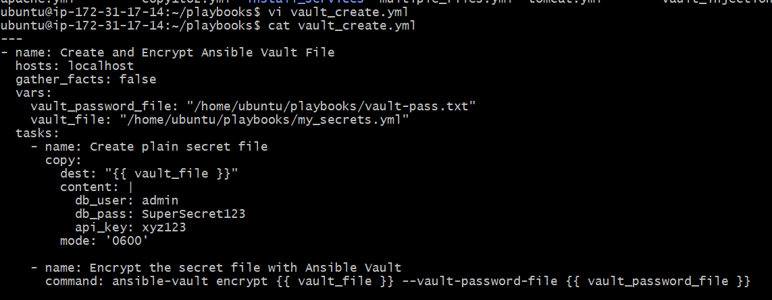

One-Time Setup, creating password for vault.
echo 'MyVaultPassword123' > vault-pass.txt
chmod 600 vault-pass.txt

ansible-playbook vault_create.yml – To run the playbook.

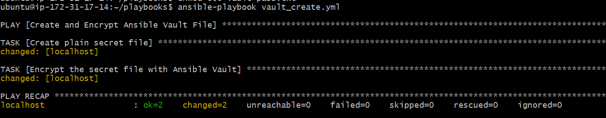

To verify the output:

ansible-vault view my_secrets.yml --vault-password-file vault-pass.txt

cat my_secrets.yml
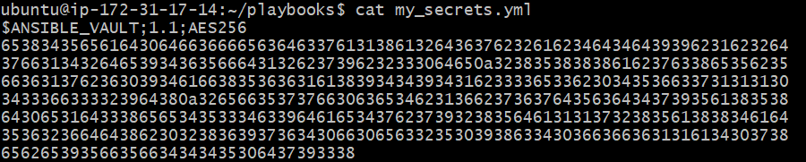

2) Write a ansible playbook to install apache in linux and ubuntu machine by using when condition.

Servers/Instances used:
Ansible controller – Ubuntu, Amazon worker – Amazon Linux 2 & Ubuntu Worker – Ubuntu.

Add sshpasswordless Authentication for linux server.
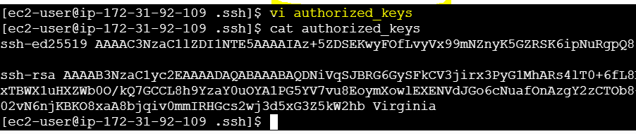

Playbook: install_apache.yml
---
- name: Install Apache on Ubuntu and Amazon Linux 2
hosts: all
become: true
gather_facts: true

tasks:
- name: Install Apache on Ubuntu
apt:
name: apache2
state: present
update_cache: true
when: ansible_distribution == "Ubuntu"

- name: Install Apache on Amazon Linux 2 using raw command
raw: sudo yum install -y httpd
when: ansible_distribution == "Amazon" and ansible_distribution_major_version == "2"

- name: Start and Enable Apache on Ubuntu
service:
name: apache2
state: started
enabled: true
when: ansible_distribution == "Ubuntu"

- name: Start and Enable Apache on Amazon Linux 2
service:
name: httpd
state: started
enabled: true
when: ansible_distribution == "Amazon" and ansible_distribution_major_version == "2"

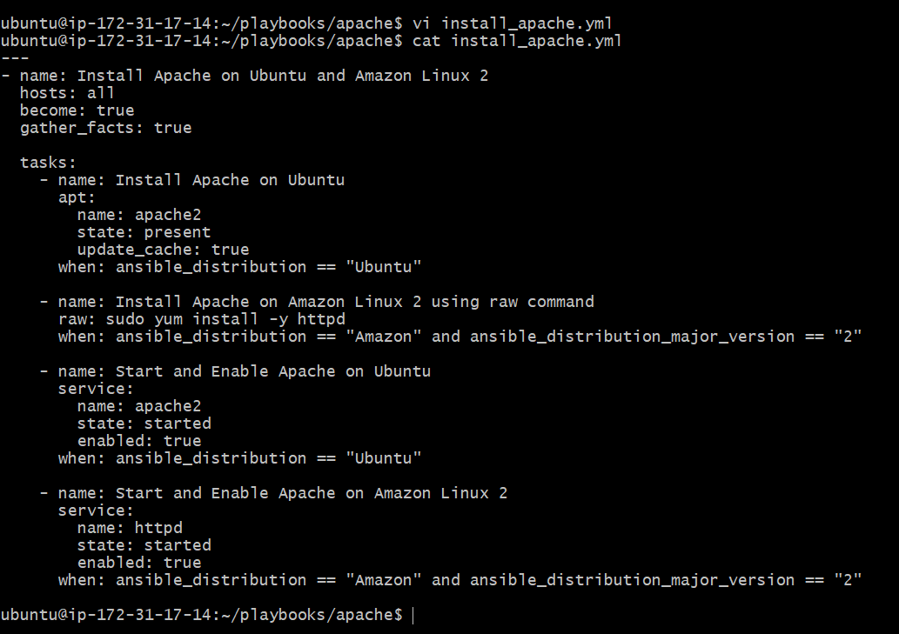

inventory.ini:

[all]
ubuntu1 ansible_host=172.31.28.151 ansible_user=ubuntu
amazon1 ansible_host=172.31.92.109 ansible_user=ec2-user

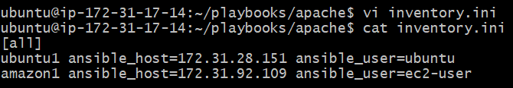

Let’s check connectivity first.

ansible all -i inventory.ini -m ping
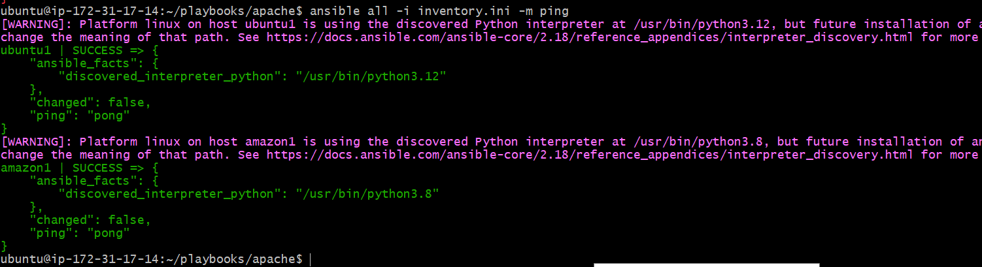

Run the Playbook
ansible-playbook install_apache.yml -i inventory.ini

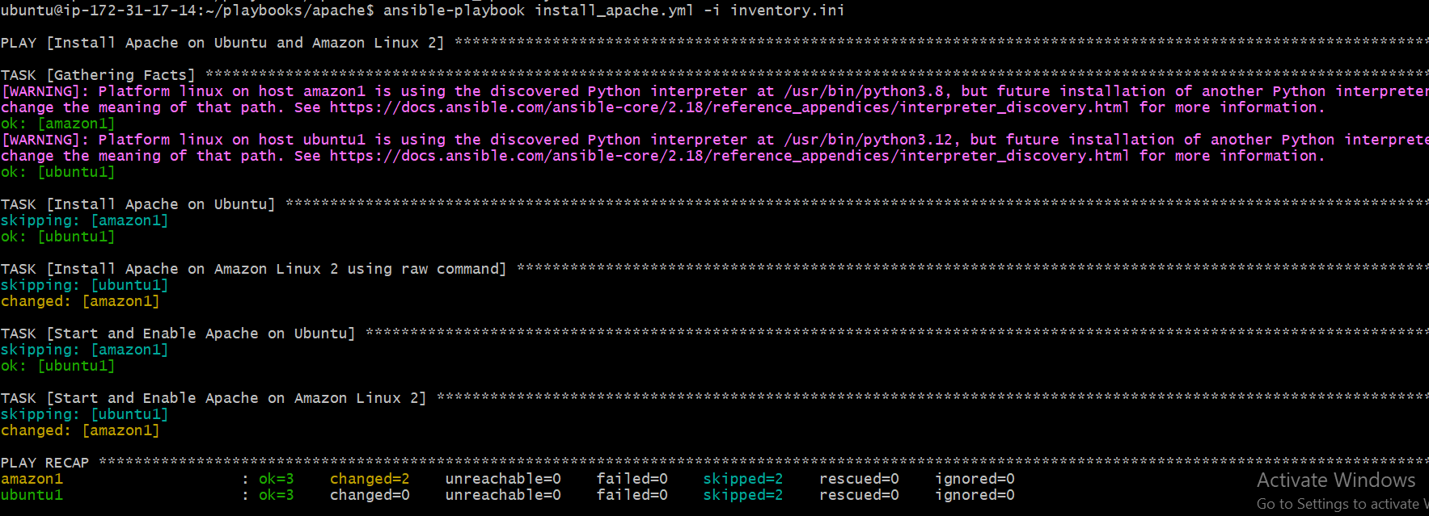

Note: Apache was already installed in ubuntu so it is showing changed=0 and its uptime is also different, we can see in verification screenshot.

Verification:
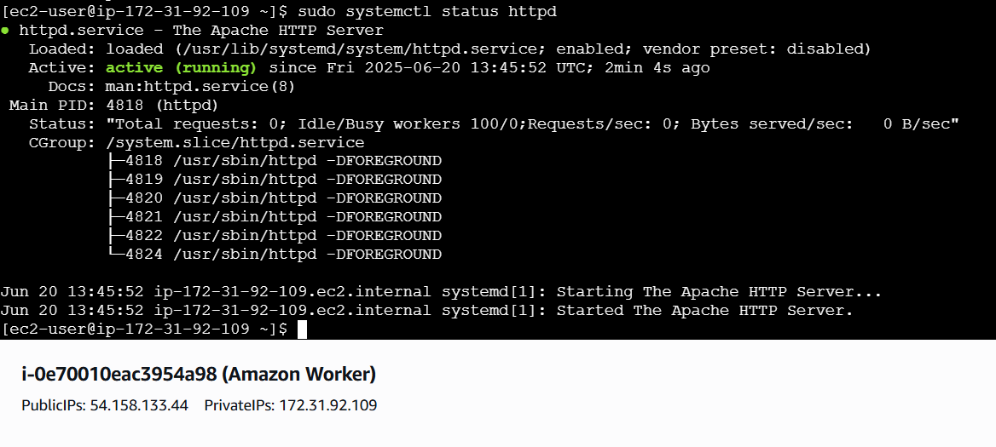

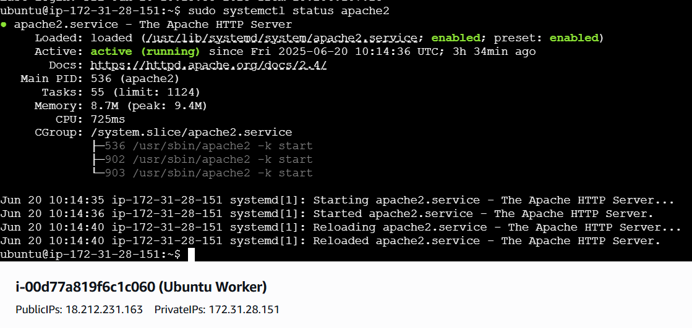

3) Create ansible playbook using roles to configure LAMP stack

Setup Directory
mkdir lamp-roles-demo && cd lamp-roles-demo
ansible-galaxy init apache
ansible-galaxy init mysql
ansible-galaxy init php

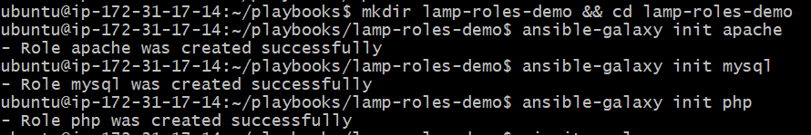
Your folder now looks like:
lamp-roles-demo/
├── site.yml
├── inventory.ini
├── apache/
├── mysql/
└── php/

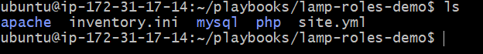

Create Your Inventory File
Create inventory.ini

[lamp]

ubuntu1 ansible_host=172.31.28.151 ansible_user=ubuntu

ubuntu2 ansible_host=172.31.25.67 ansible_user=ubuntu

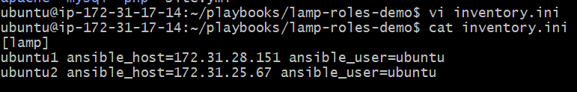

Create site.yml (Playbook)
---
- name: Install LAMP stack using roles
hosts: lamp
become: true

roles:
- apache
- mysql
- php

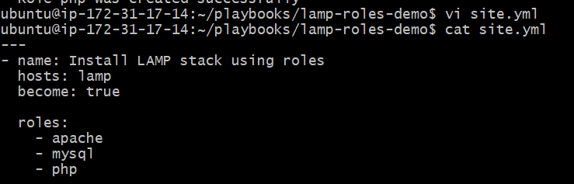

Add Role Tasks

apache/tasks/main.yml
---
- name: Install Apache
apt:
name: apache2
state: present
update_cache: yes

- name: Start and enable Apache
service:
name: apache2
state: started
enabled: yes

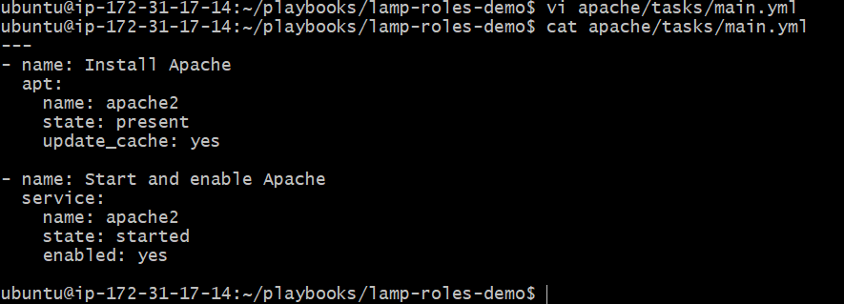

mysql/tasks/main.yml
---
- name: Install MySQL
apt:
name: mysql-server
state: present
update_cache: yes

- name: Start and enable MySQL
service:
name: mysql
state: started
enabled: yes

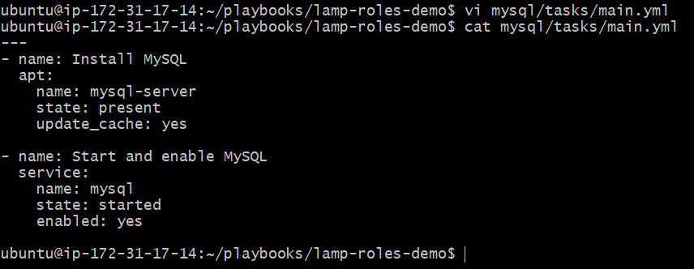

php/tasks/main.yml
---
- name: Install PHP and modules
apt:
name:
- php
- php-mysql
- libapache2-mod-php
state: present
update_cache: yes

- name: Add test PHP page
copy:
dest: /var/www/html/info.php
content: "<?php phpinfo(); ?>"

- name: Restart Apache
service:
name: apache2
state: restarted

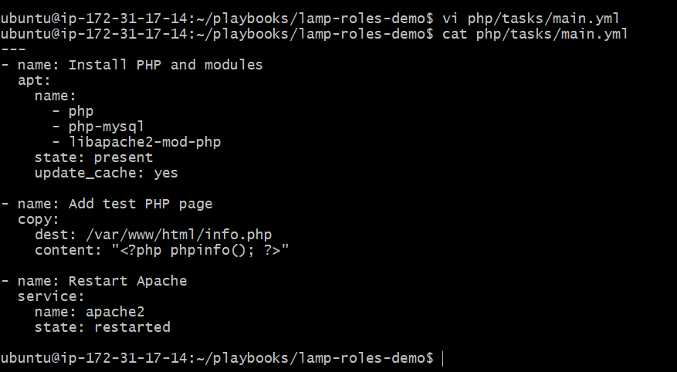

Run the Playbook
From inside lamp-roles-demo/:
ansible-playbook -i inventory.ini site.yml

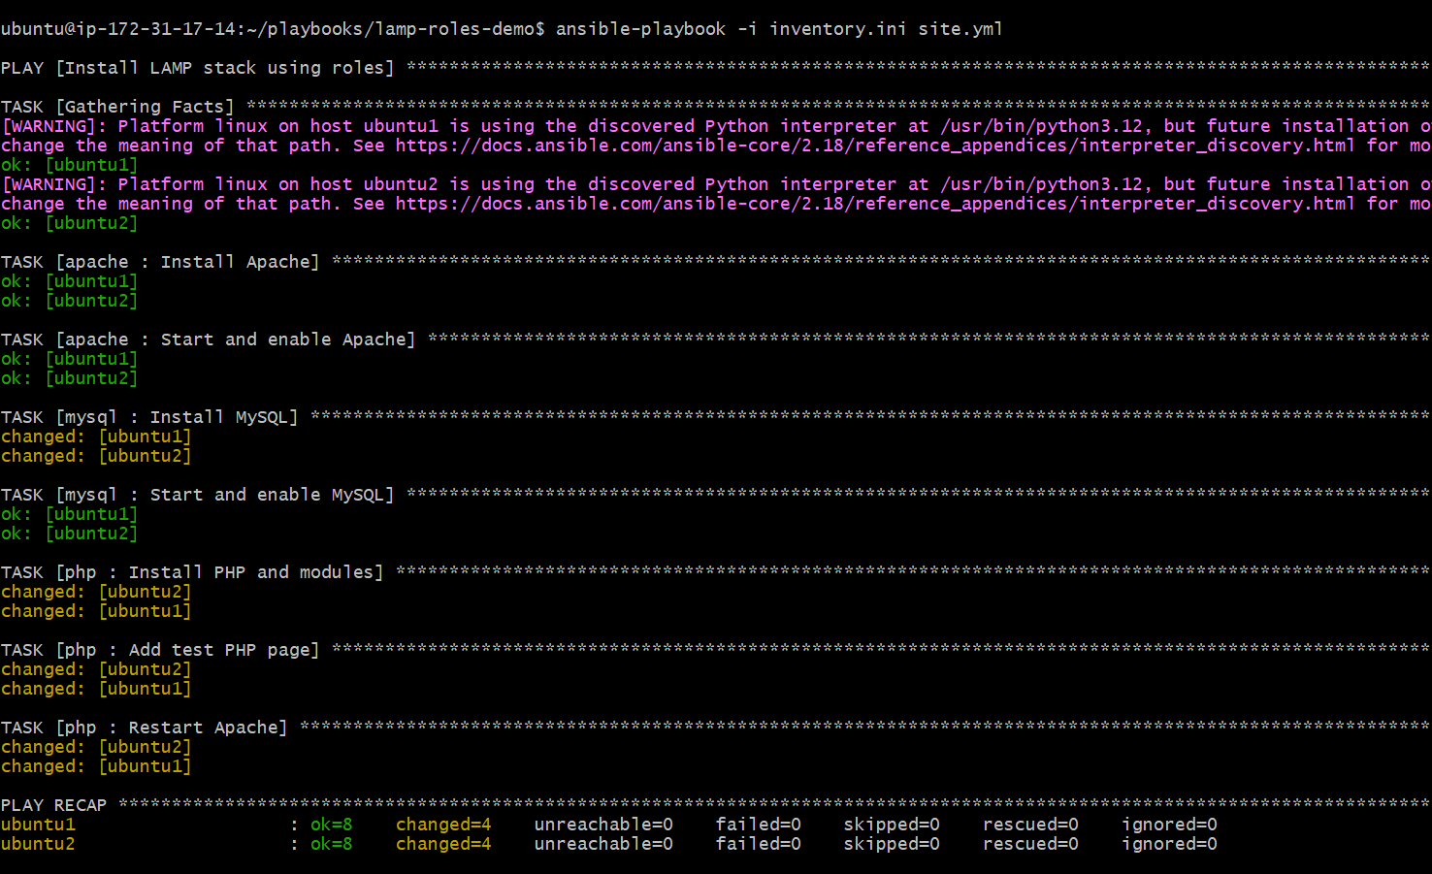

Validate It Works

Worker - 01
In your browser:
http://18.212.231.163/info.php

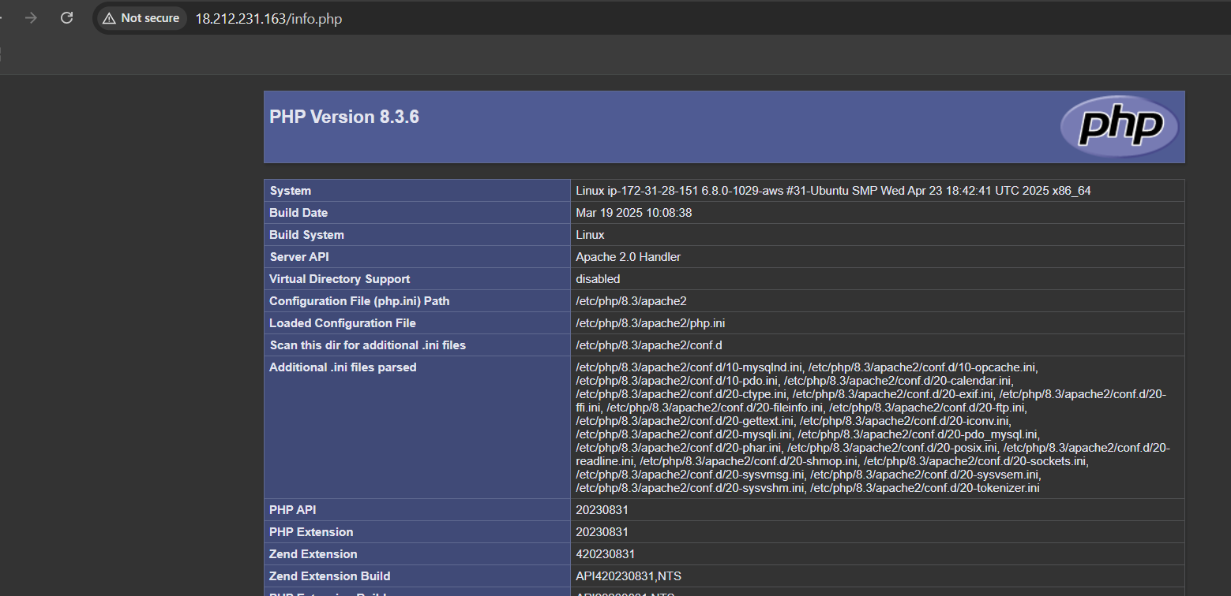

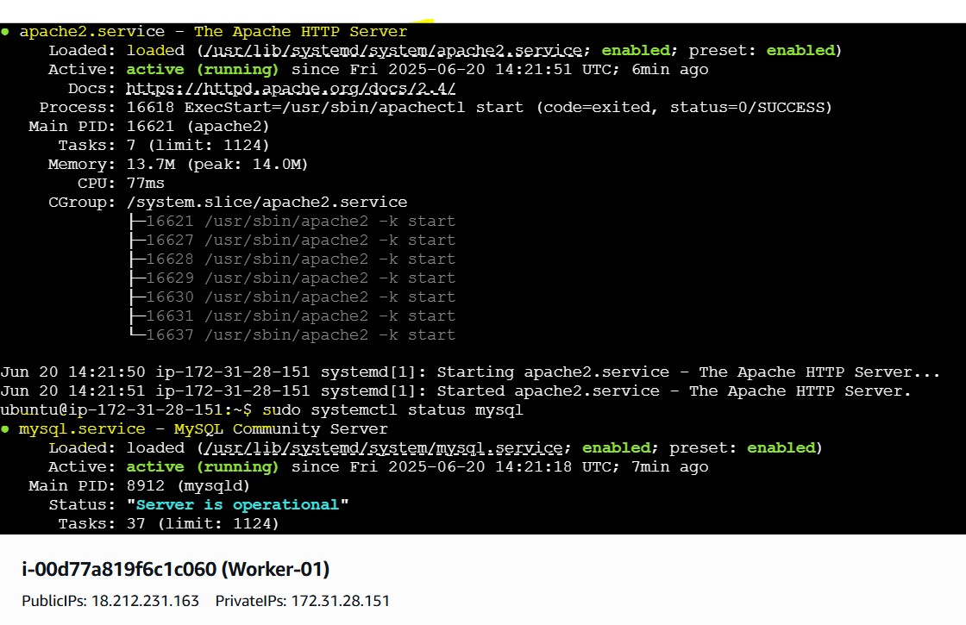

Worker - 02
In your browser:
http://18.212.80.10/info.php

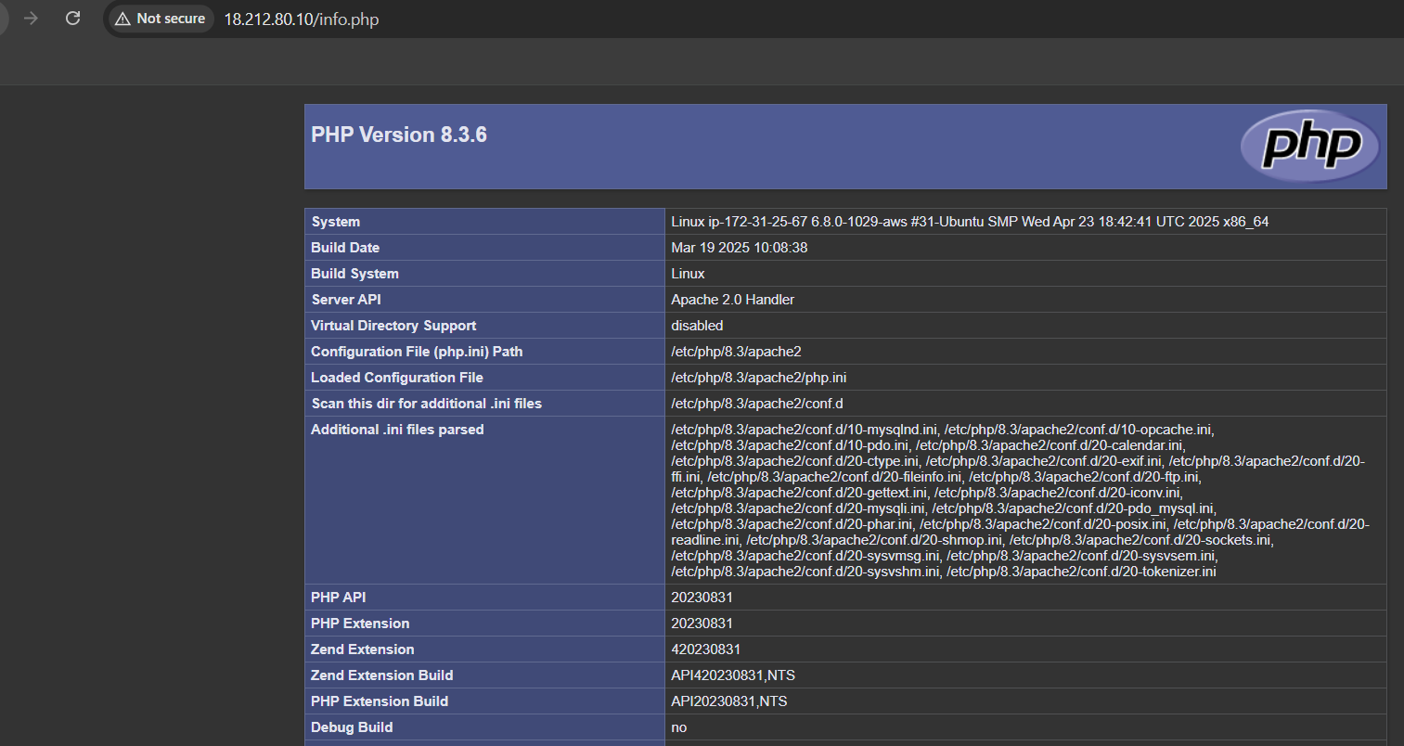

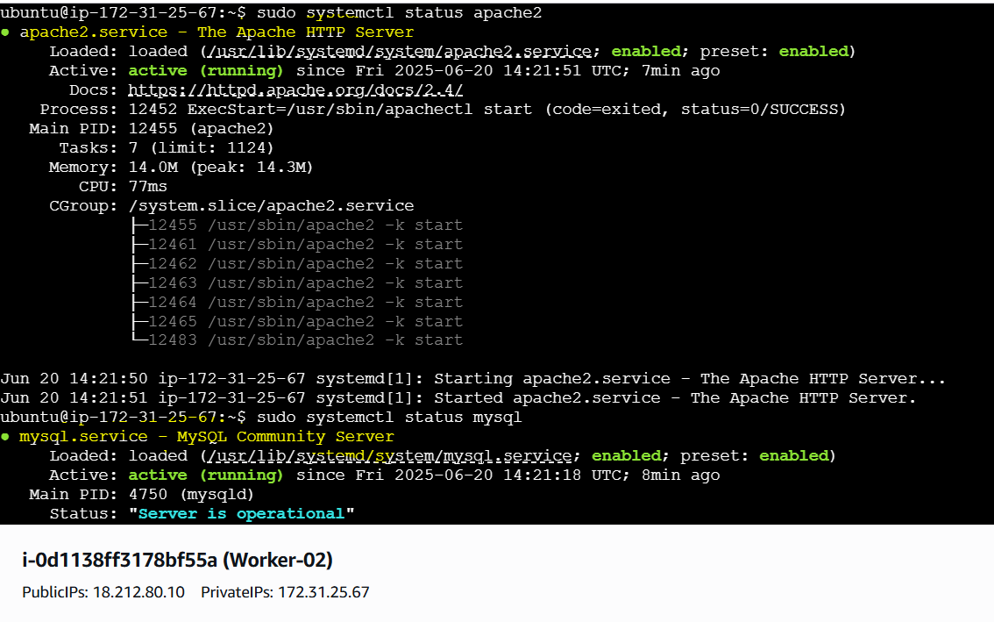

Default Role directory structure.

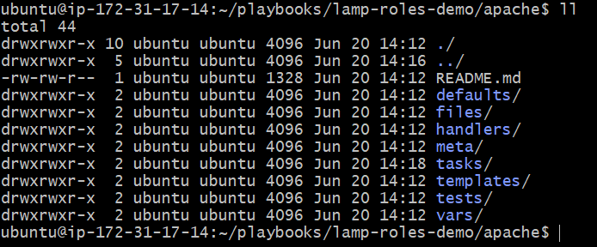

defaults/ – Contains default variables for the role with the lowest precedence.
files/ – Stores static files to be copied to the target system.
handlers/ – Defines actions (like service restarts) triggered by task notifications.
meta/ – Provides metadata about the role, such as dependencies or author info.
tasks/ – Holds the main list of tasks that the role will execute.
templates/ – Contains Jinja2 templates for dynamically generated files.
tests/ – Includes sample inventory and test playbooks to validate the role.
vars/ – Stores variables with higher precedence than defaults.
README.md – Describes the purpose, usage, and structure of the role.

4) Setup ansible AWX and explore the options.

AWX Setup on Ubuntu

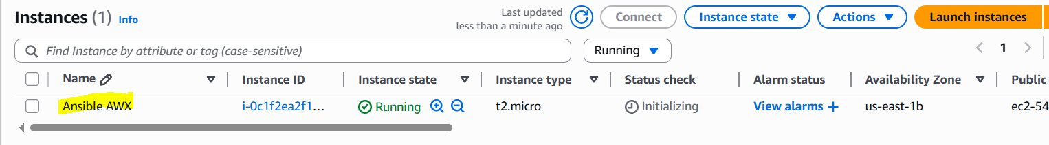

System Update & Install Dependencies
sudo apt update -y && sudo apt upgrade -y

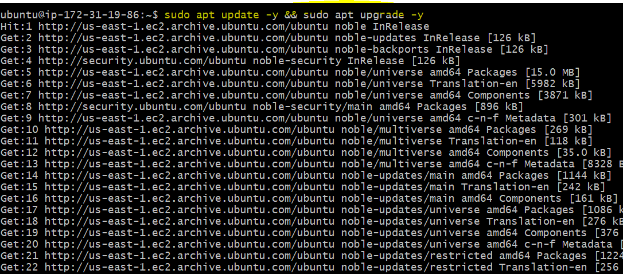

Install required tools
sudo apt install -y git gcc g++ ansible nodejs gettext \
libffi-dev python3-pip python3-dev libyaml-dev \
docker.io docker-compose nano wget curl bzip2

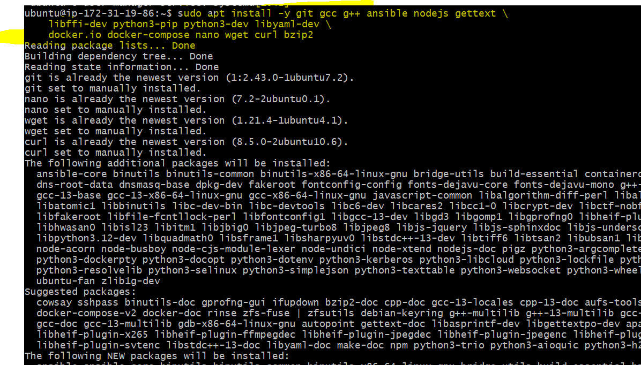

sudo systemctl status docker

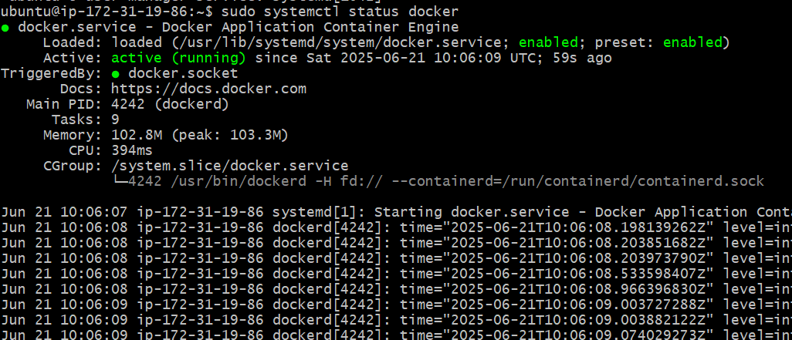

Install Python PIP Packages
pip3 install --upgrade pip setuptools_rust wheel docker-compose --break-system-packages

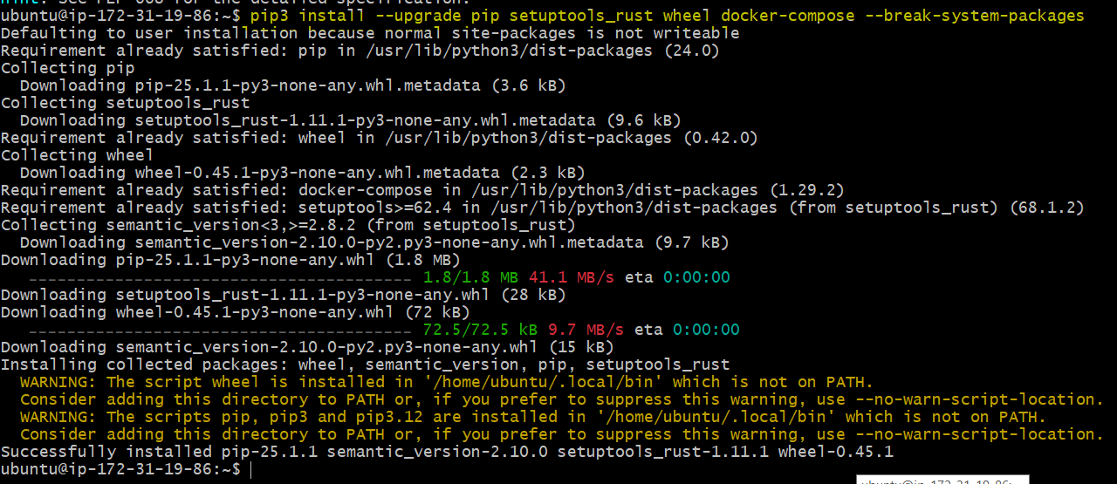

Clone the AWX Source Code
cd ~
git clone -b 17.1.0 https://github.com/ansible/awx.git
cd awx

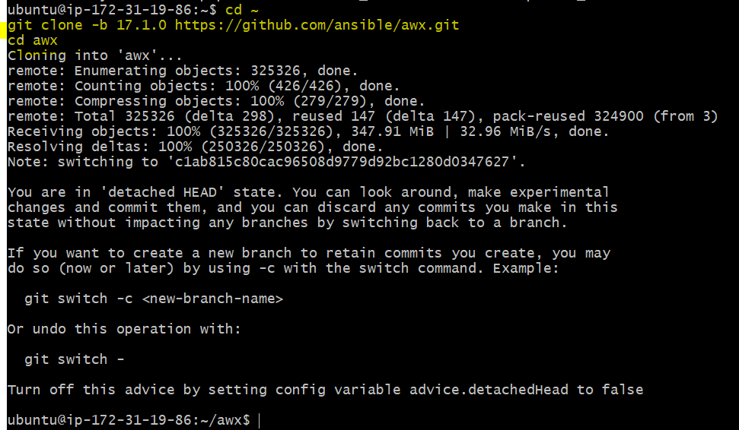

Configure the AWX Installer
Edit the inventory file:
vi ~/awx/installer/inventory
Uncomment and update these variables:
[all]
localhost ansible_connection=local

[all:vars]
admin_user=admin
admin_password=Admin@123
secret_key=Admin@123
pg_password=Admin@123
pg_database=awx
pg_username=awx
awx_alternate_dns_servers="8.8.8.8,8.8.4.4"
postgres_data_dir="/var/lib/awx/pgdocker"
docker_compose_dir="/var/lib/awx/awxcompose"
project_data_dir="/var/lib/awx/projects"

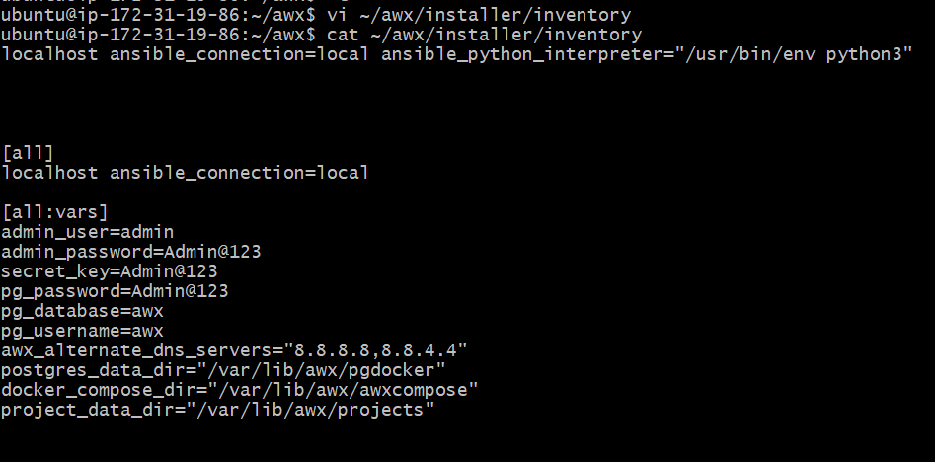

Run the AWX Installer
ansible-playbook -i ~/awx/installer/inventory ~/awx/installer/install.yml
This will set up AWX with Docker Compose, PostgreSQL, and Redis containers.
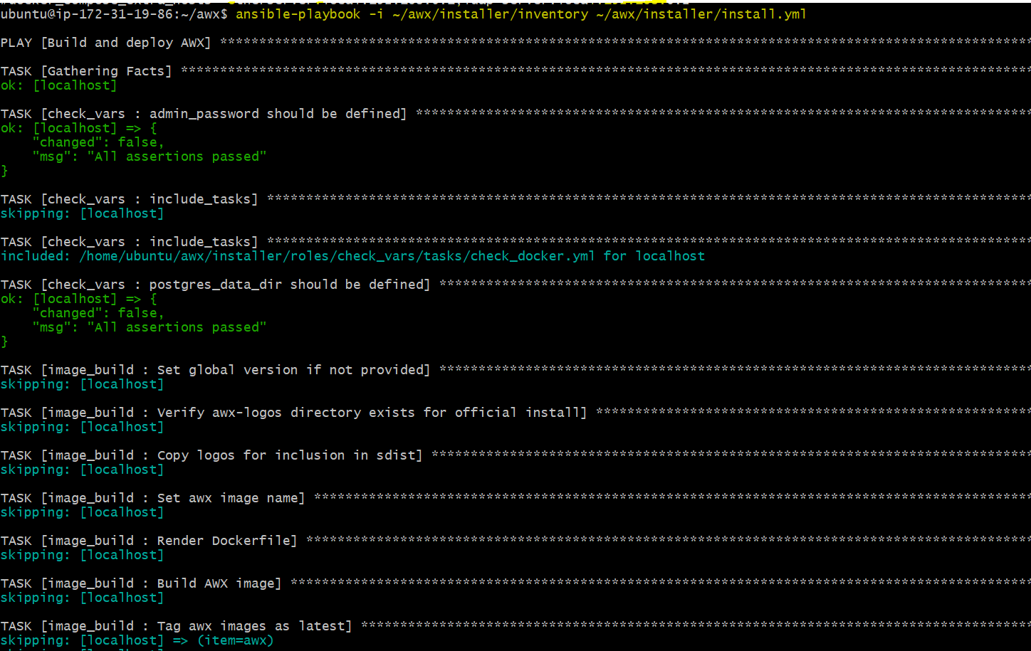

Check Docker Containers
docker ps
You should see containers like:
- awx_task
- awx_web
- postgres
- redis

Access the AWX Web UI
Open this in your browser:
http://<your-public-ip>:80
Use the credentials:
- Username: admin
- Password: Admin@123

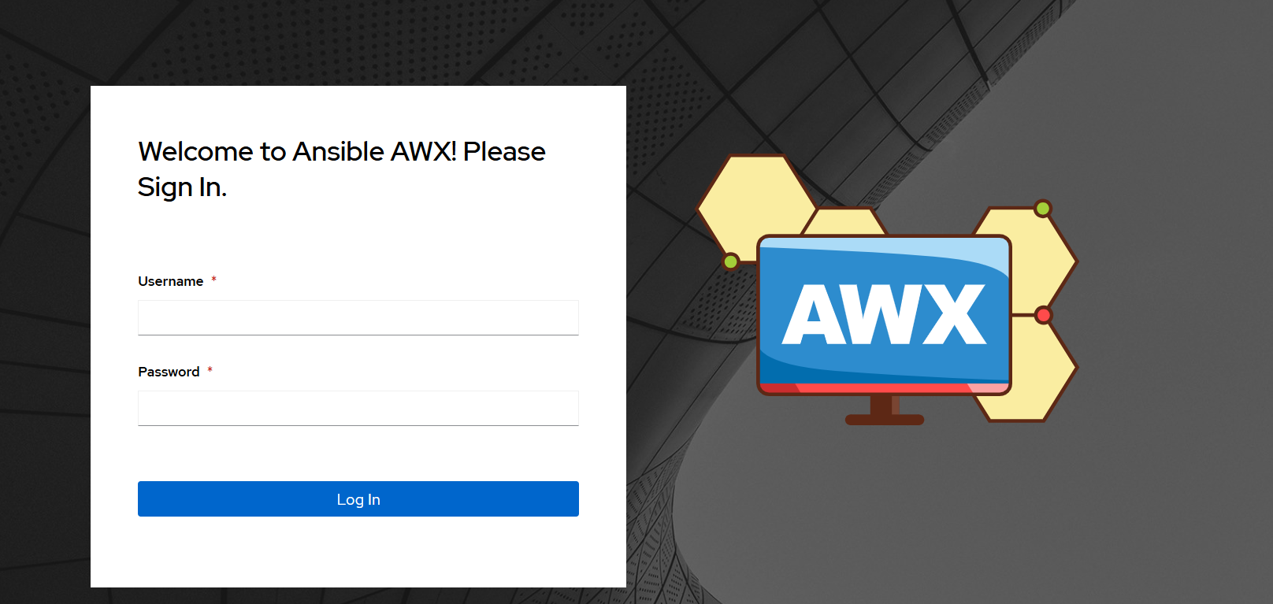

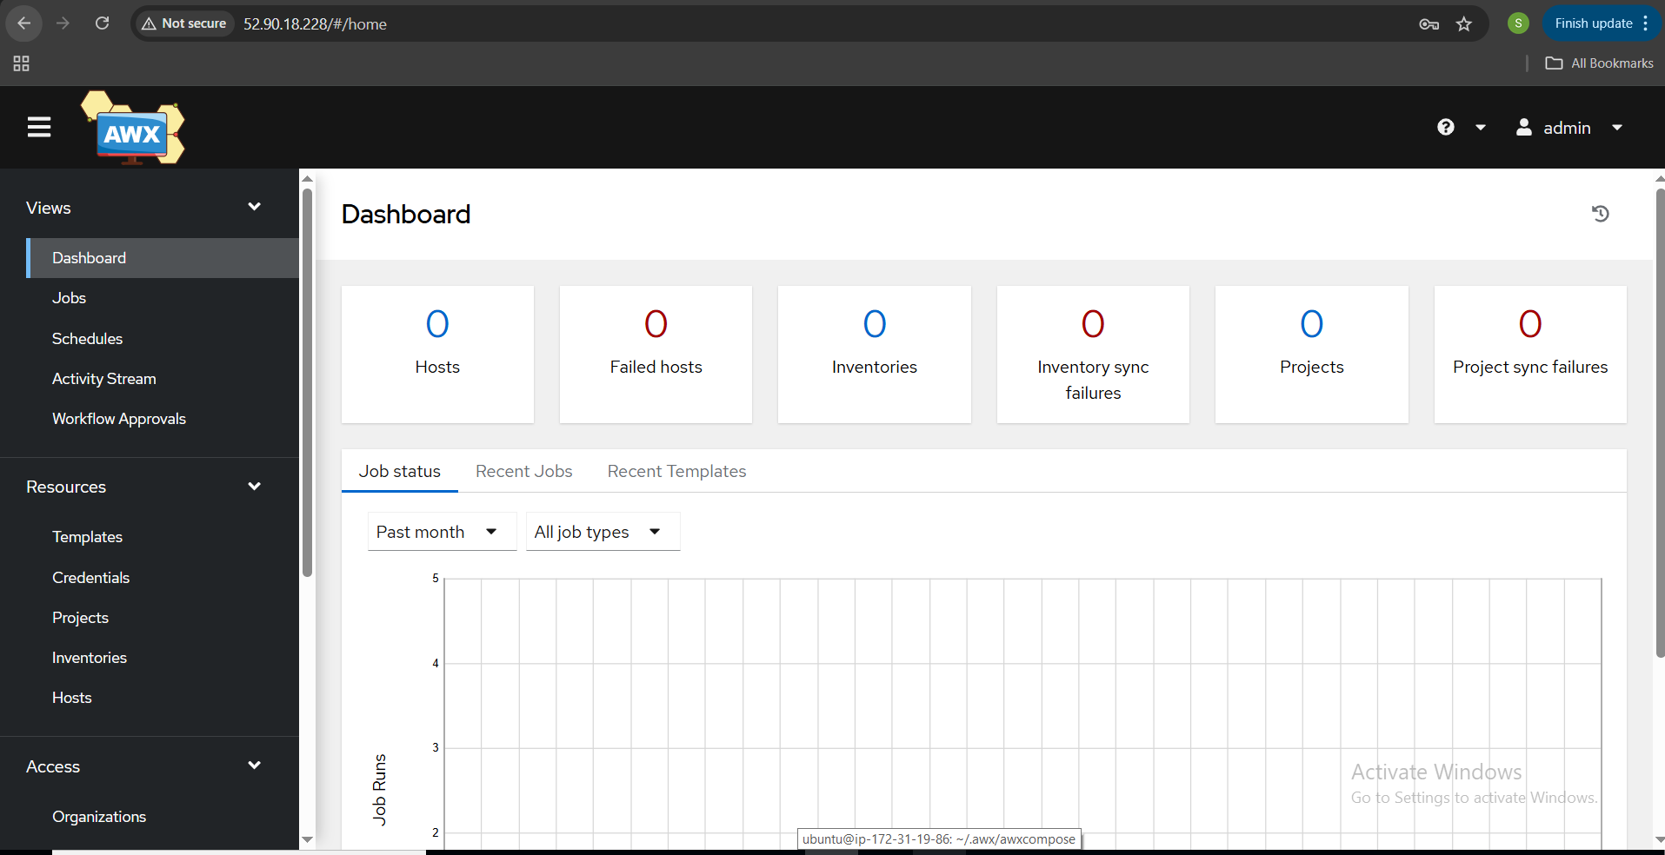

Dashboard – Overview of system activity, job statuses, and recent events.
Jobs – List of executed job templates and workflow runs with status and logs.
Schedules – Define automated triggers for jobs to run at specific times.
Activity Stream – Real-time audit log of all user and system activities.
Workflow Approvals – Approve or deny manual steps in workflow job templates.
Templates – Define job or workflow templates for repeatable automation.
Credentials – Store authentication details securely for access in jobs.
Projects – Link to source control repositories containing playbooks.
Inventories – Define groups of hosts that jobs run against.
Hosts – Individual machines managed under an inventory.
Access – Assign role-based permissions to users and teams.
Organizations – Logical grouping of users, teams, and resources.
Users – Manage individual user accounts and access levels.
Teams – Group users together for easier role assignment.
Credential Types – Define custom formats for new credential kinds.
Notifications – Configure alerting methods (email, Slack, etc.) for events.
Management Jobs – Predefined jobs for cleanup, diagnostics, etc.
Instance Groups – Define execution environments and scale job runs.
Applications – Register OAuth2 apps for API authentication.
Settings – System-wide configurations like authentication, logging, etc.

THE-END

